Hills:

Chitral

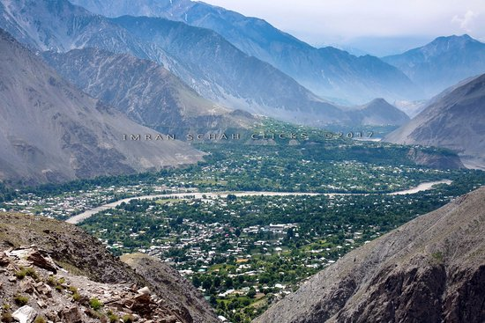

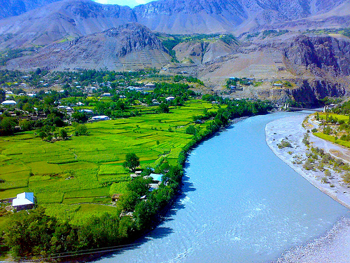

**Chitral** Khowar : Khowar for "field") is the capital of the Chitral District, situated on the Chitral River in northern Khyber Pakhtunkhwa, Pakistan. Chitral also served as the capital of the princely state of Chitral until 1969.

Swat

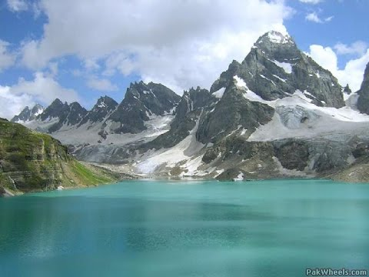

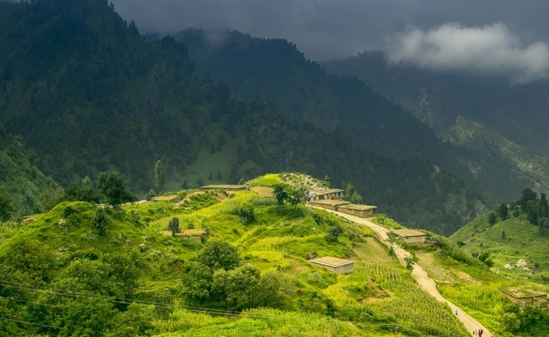

**Swat District** is a district in Malakand Division of Khyber Pakhtunkhwa province in Pakistan. Swat is renowned for its outstanding natural beauty.Centred upon the upper portions of the Swat River, Swat was a major centre of early Buddhist thought as part of the Gandhara kingdom, and today is littered with ruins from that era. Swat was home to the last isolated pockets of Gandharan Buddhism, which lasted until the 11th century, well after most of the area had converted to Islam. Until 1969, Swat was part of the Yusafzai State of Swat, a self-governing princely state. The region was seized by the Pakistani Taliban in late 2007, and its tourist industry decimated until Pakistani control over Swat was re-established in mid 2009.

Bhurban

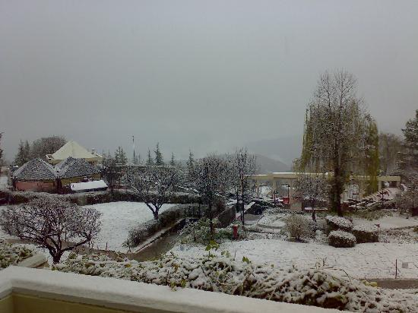

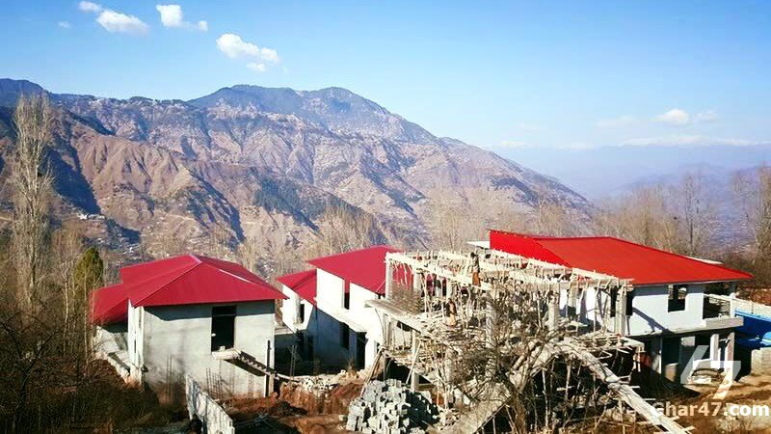

**Bhurban** is a small town and a hill station in Punjab province, Pakistan. The resort town is named after a nearby forest. It is located approximately 9 kilometres from Murree city. Bhurban is one of the more picturesque places in the country, and is a tourist paradise with unique flora, and a fauna with a variety species not found elsewhere in Pakistan. It is known for scenic hiking trails in the nearby Ayubia National Park. The '5 star' Pearl Continental Hotel - Mount Pleasant Apartments is one of several resorts in Bhurban that serve tourists visiting the Murree Hills and the national park. Bhurban also has a nine-hole golf course. Another beautiful resort in Bhurban is the Bhurban Hill Apartments, located 2km from PC Bhurban. It has its own source of natural mineral water.

Nathia Gali

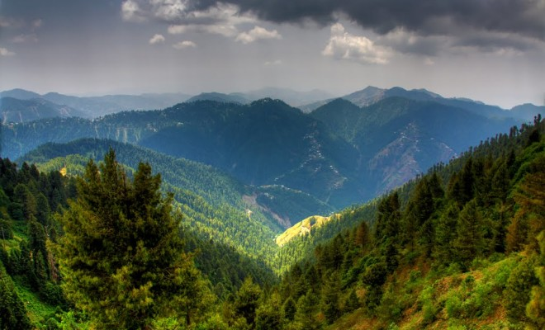

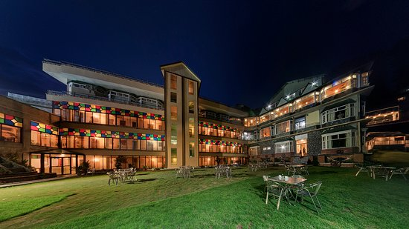

**Nathia Gali** or **Nathiagali** is a mountain resort town or hill station in Abbottabad District of Khyber Pakhtunkhwa, Pakistan. It is located at the center of the Galyat range, where several hill-stations are situated, closely connected to each other, and with their names mostly ending in 'Gali'. Nathiagali is known for its scenic beauty, hiking tracks and pleasant weather, which is much cooler than the rest of the Galyat due to it being at a greater altitude. It is situated 32 kilometers at one hour's drive away from both Murree and Abbottabad, lying midway between these two places. The drive time from Islamabad is usually about three hours, unless there is a lot of traffic.

shogran

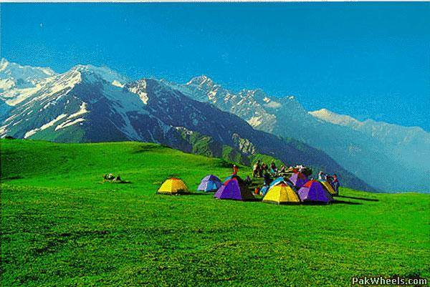

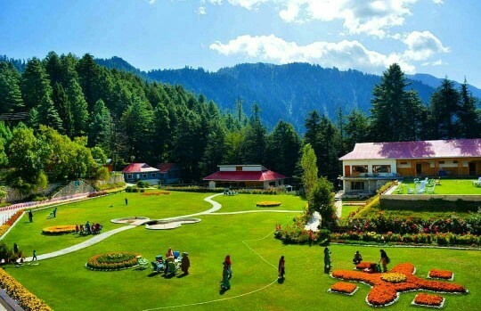

**Shogran** is a hill station situated on a green plateau in the Kaghan Valley, northern Pakistan at a height of 2,362 metres (7,749ft) above sea level. Shogran is located at a distance of 34 kilometres (21mi) away from Balakot. The road from Islamabad to Kiwai is metalled and measures 212 kilometres (132mi). Hotels and motels are available at affordable costs. Mobile phone services is also available there by Telenor and Mobilink. The local people are friendly and peaceful. It is accessible in the summer. It attracts families and explorers alike. You should not miss a trip to Forest Rest House. Most of the people sit and relax in its huge lush green lawns. Entry might be restricted when senior officials visit or stay at rest houses. Views of Sri Paya and 'Musa ka Musala Peak' are really nice from the lawns of the rest house.

Khanspur

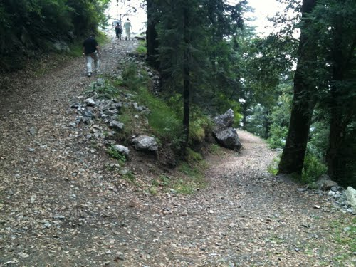

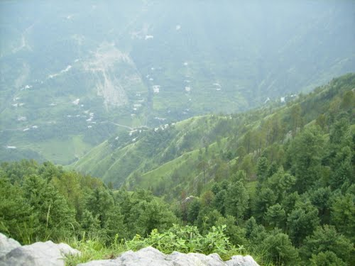

**Khanaspur** is one of the tourist mountain resort towns of the Galyat area of Hazara region of the Khyber Pakhtunkhwa. Khanaspur is a settlement in the Ayubia area and is located in Abbottabad District in Khyber Pakhtunkhwa province of Pakistan. It also has the Punjab University Hostel. It also had the Bhutto House. During British rule it was occupied by a detachment of British infantry. It is situated at an altitude of about 2,250 metres (7,382 ft).

The average temperature during the months of June–September ranges from 21 °C to 26 °C with cool nights. During winter, snowfall is common with tropical alpine environment.